# Lab Statement 1:

**Q.1**

TCP port=80

IP address= 192.168.1.102



**Q.2**

TCP port=1161

IP address= 128.119.245.12

**Q.3**

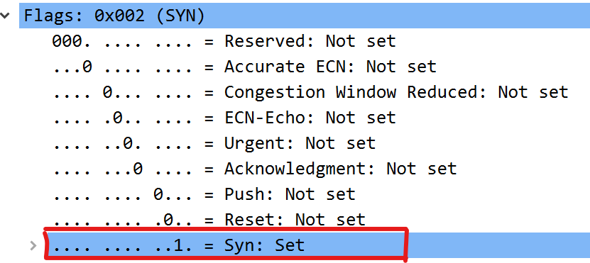

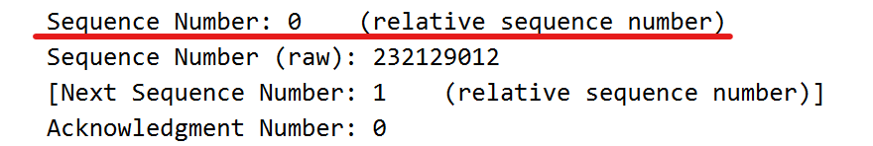

**Q.4**

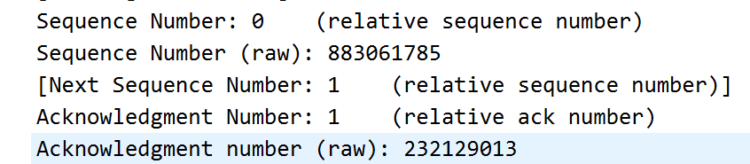

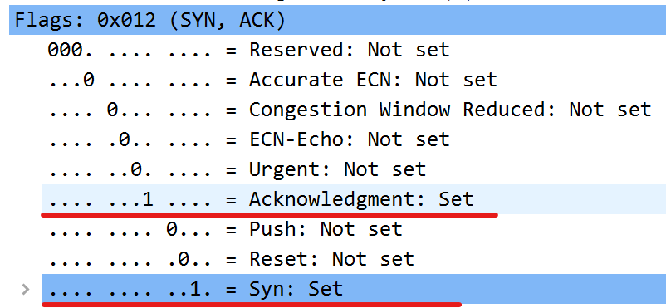

**Q.5**

The Acknowledgment number (Ack) of 2026 means the sender acknowledges the successful receipt of data up to sequence number 2026 from the receiver.

The Sequence number (Seq) of 1 indicates that the data in this packet starts with the sequence number 1.

**Q.6**

The Acknowledgment number (Ack) of 7866 means the sender acknowledges the successful receipt of data up to sequence number 7866 from the receiver.

The Sequence number (Seq) of 1 indicates that the data in this packet starts with the sequence number 1.

**Q.7**

1. Simplifies Analysis
2. Improves Readability
3. Highlights Data Movement

# Lab Statement 2:

**Q.1**

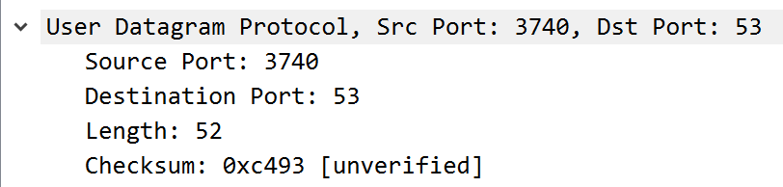

4 fields.

**Q.2**

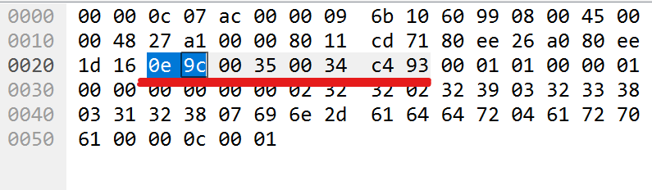

Every header is of 2 bytes so a total of 8 bytes.

**Q.3**

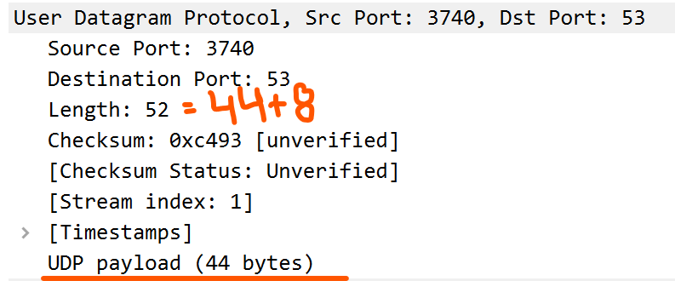

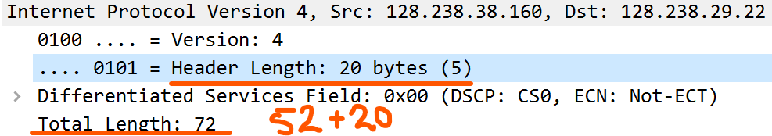

**Q.4**



# Lab Statement 3:

|  |
| --- |
| 1. Are ICMP messages sent over UDP or TCP?     They are not sent over TCP or UDP, they have their own protocol. |
| 1. What is the link-layer (e.g., Ethernet) address of the host?     Source: Tp-LinkT_87:05:fe (c0:4a:00:87:05:fe)  Destination: IntelCor_55:7b:ac (60:67:20:55:7b:ac) |
| 1. Which kind of request is sent through these ICMP packets?     Type: 8 request which is used for ping requests |
| 1. How many requests are sent through the host?   4 requests are sent through the host. |
| 1. What is the IP address of your host? What is the IP address of the destination host?     The IP Address of the host is: 192.168.33.100  The IP Address of the Destination is: 172.217.27.36 |
| 1. Why is it that an ICMP packet does not have source and destination port numbers?   ICMP operates at the network layer, it doesn't require source and destination port numbers. |
| **7-** What values in the ICMP request message  differentiate this message from the ICMP reply message?  The Type field helps in differentiating the request and reply message from each other. |
| 1. Examine one of the ping request packets sent by your host. What are the ICMP type and code numbers? What other fields does this ICMP packet have? How many bytes are the checksum, sequence number and identifier fields?   ICMP Type number is 8 (ECHO (ping) request) with code 0. It contains Checksum, Checksum Status, Identifier (BE & LE), Sequence Number (BE & LE). Checksum, Identifier and Sequence fields are of 2 bytes each. |
| **9-** Examine the corresponding ping reply packet. What are the ICMP type and code numbers? What other fields does this ICMP packet have? How many bytes are the checksum, sequence number and identifier fields?  Type number 0 (ECHO (ping) reply) with code 0. It contains Checksum, Checksum Status, Identifier (BE & LE), Sequence Number (BE & LE). Checksum, Identifier and Sequence fields are of 2 bytes each. |
| **10-**Examine the packet no 56. What are the ICMP type and code numbers? Why is the IP and TCP Header included in the ICMP Header? What does these headers depict?    So, when packet fails it generates an ICMP destination unreachable and port unreachable message (type 3, code 3). To tell the sender more about the error ICMP message include first 8 bytes of original IP packet’s header and some portion of payload. The first 8 bytes of IP header includes source and destination IP addresses and other information. The portion of payload includes source and destination port numbers. So, IP header depicts source and destination IP addresses and TCP header depicts source and destination port numbers |